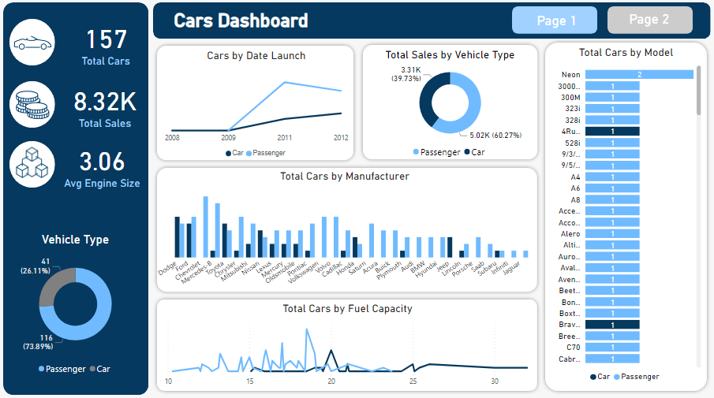

https://www.google.com/url?sa=i&url=https%3A%2F%2Fmedium.com%2F%40ahmedemad2893%2Fcars-dashboard-5b2046db5dee&psig=AOvVaw2jVjyIBpXJnV_YvaUDj6Al&ust=1749228251501000&source=images&cd=vfe&opi=89978449&ved=0CBQQjRxqFwoTCMjCg7jd2o0DFQAAAAAdAAAAABAE

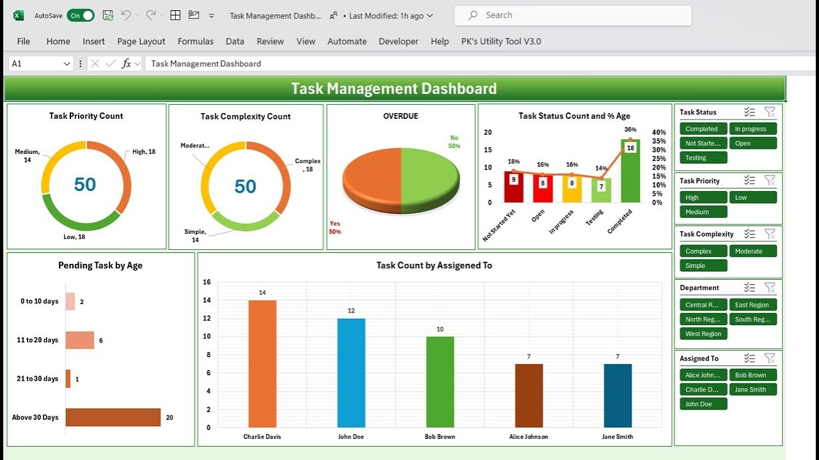

https://www.google.com/url?sa=i&url=https%3A%2F%2Fwww.youtube.com%2Fwatch%3Fv%3DEjiB4klt2Uc%26pp%3D0gcJCfcAhR29_xXO&psig=AOvVaw0qy-ESrLlYHfam4Kdv1Eos&ust=1749228341743000&source=images&cd=vfe&opi=89978449&ved=0CBQQjRxqFwoTCJC129_d2o0DFQAAAAAdAAAAABAE

